

CAPSTONE PROJECT REPORT
Report 2 – Project Management Plan

– Hanoi, Sep 2026 –
Table of Contents
Change Log 3
I. Project Overview 4
1. Scope and Purpose 4
2. Assumptions & Constraints 4
3. Cost & Time Estimations 5
4. Capacity Planning 7
5. Project Objectives 7
6. Risks and Mitigations 8
II. Management Approach 10
1. Project Process/Methodology 10
1.1 Process Model Overview 10
1.2 Scrum Roles & Responsibilities 10
1.3 Scrum Events (Ceremonies) 11
2 Quality Management 11
2.1 Definition of Ready (DoR) and Definition of Done (DoD) 11
2.2 Defect Prevention 12
2.3 Continuous Review Process 12
2.4 Testing Strategy 12
2.5 Defect Management Workflow 13
3. Project Training Plan 13
4. Responsibility Assignments 14
4.1. Project Organization 14
4.2. Role and Responsibilities 14
4.3. Responsibility Assignment Matrix 15
5. Project Communications 16
6. Configuration Management 17
6.1 Document Management 17
6.2 Source Code Management 18
6.3 Tools & Infrastructures 19

Change Log
Date | A*  M, D | In charge | Change Description
18/9/2026 | A | HuyNV | Add Project Overview
18/9/2026 | A | XumLM,  DuND,  ThuongNQ,  TuTB | Add Management Approach
25/9/2026 | M | HuyNV, DuND | Edit Cost & Time Estimations + Project Process/Methodology
*A - Added M - Modified D - Deleted

I. Project Overview

1. Scope and Purpose

The AgriSustain project is designed to address supply-demand disruptions and agricultural value chain transparency through an e-commerce platform integrated with product traceability. The project scope focuses on delivering core functionalities including multi-role authentication, user account management for sellers and buyers, agricultural product search and ordering, product management, QR code-based traceability linked to individual batches, synchronized order processing, review and complaint management, and revenue analytics. To ensure feasibility within the capstone project timeframe, the project excludes certain elements such as integrating third-party physical logistics fleets, deploying IoT physical sensors in fields, implementing decentralized blockchain networks, and developing native mobile applications for Android/iOS (focusing solely on responsive web applications). Regarding its relationship with other systems, AgriSustain bridges the gaps of existing solutions by offering an open B2B and B2C marketplace unlike closed B2B platforms (such as Voso, Freso); integrating a direct trading marketplace instead of acting merely as an independent QR-scanning tool (such as iCheck, CheckVN); and embedding regional price data directly into daily commercial transactions rather than stopping at macro-level reference statistics (such as FAO, AGMARKNET).

2. Assumptions & Constraints

No | Description | Note
Assumptions
1 | Project stakeholders (Instructors and Defense Council) will review and approve milestone documents within 3 working days. If no feedback is received within this timeframe, it will be considered approved. | External Interfaces
2 | Sellers (Farmers/Business households) are responsible for providing and accurately updating legal information, farming logs, pricing, and product images on the system. | Scope
3 | Users will access the AgriSustain platform using standard internet-connected devices (web browsers on computers or mobile phones) without requiring special hardware. | Resources
Constraints
1 | The entire project must be completed and the system delivered before the deadline of the SEP490 semester in December 2026. | Schedule
2 | The project must comply with information security regulations, user data privacy, and password encryption according to secure software development standards. | Security
3 | The system must be developed as a Responsive Web Application using React (frontend) and ASP.NET Web API 8.0 (backend), excluding standalone native mobile applications within the scope of this capstone project. | Software / Technology

3. Cost & Time Estimations

# | Work Package | Effort (pds) | Due Date
1 | Phase 1: Initiation & Product Backlog (Weeks 1–3) | 42
1.1 | Project initiation, team roles, Git/environment setup | 7 | Week 1
1.2 | Report 1: Project Introduction v1.0 | 6 | Week 2
1.3 | Requirement analysis, product backlog, UC review and prioritization | 12 | Week 3
1.4 | Report 2: Project Management Plan v1.0 | 7 | Week 3
1.5 | Report 3: Software Requirement Specification v1.0 | 10 | Week 3
2 | Phase 2: Architecture & Sprint Preparation (Weeks 4–5) | 43
2.1 | UI/UX wireframes and screen flow for core functions | 14 | Week 4
2.2 | Database design, ERD and technical architecture | 9 | Week 4
2.3 | Report 4: Software Design Specification v1.0 | 12 | Week 5
2.4 | Test strategy, test plan and baseline test cases | 8 | Week 5
3 | Phase 3: Sprint Implementation & Unit Testing (Weeks 6–11) | 124
3.1 | Sprint 1 — Iteration 1: Authentication, Marketplace, Traceability, Farm foundation and core Administration | 46 | Week 7
3.2 | Sprint 2 — Iteration 2: Consumer ordering/payment, Farmer sales, B2B procurement, moderation and complaint handling | 48 | Week 9
3.3 | Sprint 3 — Iteration 3: B2B contracts, subscription, certification, analytics and advanced administration | 30 | Week 11
4 | Phase 4: Integration & System Verification (Week 12) | 38
4.1 | Integration testing, regression testing and bug fixing | 20 | Week 12
4.2 | System testing, performance checks and security baseline review | 12 | Week 12
4.3 | Test execution evidence and test report completion | 6 | Week 12
5 | Phase 5: UAT & Deployment (Weeks 13–14) | 28
5.1 | UAT support, feedback processing and critical bug fixing | 15 | Week 13
5.2 | Report 6: Installation Guide and User Manual | 5 | Week 13
5.3 | Release candidate, deployment and production verification | 8 | Week 14
6 | Phase 6: Closing & Handover (Week 15) | 16
6.1 | Report 7: Final Project Report | 6 | Week 15
6.2 | Presentation file and rehearsal | 4 | Week 15
6.3 | Handover, retrospective and final minor fixes | 6 | Week 15
 | TOTAL PLANNED EFFORT | 291 pds

4. Capacity Planning

Item | Value
Hours per person per week | 40 h (8 h/day × 5 days)
Team total per week | 200 h/week (5 people × 40 h)
Total duration | 10 weeks
Gross capacity | 2,000 h (200 h/week × 10 weeks)
Buffer (meetings, reviews, unplanned — 20%) | 400 h (2,000 × 20%)
Effective working capacity | 1,600 h (2,000 × 80%)

5. Project Objectives

# | Metric | Unit | Planned | Actual | Notes / References
1 | Effort Usage | Person-day | 291 | 291 | Need to analyze more for the actual effort distribution (as tracked in the Project Tracking, sheet Scope).
2 | Review Defects | No. of defects | 45 | 38 | Performed to identify defects at an early stage.
3 | Unit Test Defects | No. of defects | 38 | 32 | Written and executed by software developers to ensure that each software unit meets its design and behaves as intended.
4 | Integration Test Defects | No. of defects | 30 | 25 | Individual software modules are combined and tested as a group.
5 | System Test Defects | No. of defects | 12 | 8 | Performed on the entire system to verify both system design and behavior against expected requirements.
6 | Acceptance Test Defects | No. of defects | 5 | 0 | Performed by users based on real-life usage scenarios.
7 | Timeliness | % | 90 | 90 | Total on-time deliverables / Total project deliverables.
8 | Requirement Completeness | % | 85 | 90 | Failed if ≤ 75%.

6. Risks and Mitigations

# | Risk | Prob | Impact | Mitigation
1 | Difficulty in understanding business requirements | High | High | Study similar business websites and existing solutions to better understand the requirements. Communicate with customers and clarify unclear requirements as early as possible.
2 | Team members do not spend enough time on the capstone project | High | High | Set clear daily work commitments from the beginning. Team members must report problems early so that other members and instructors can provide timely support.
3 | Clients frequently change requirements or expand project scope | Medium | Medium | Define the project scope clearly at the beginning. Review the scope regularly and discuss any requested changes with the customers and instructors before implementation.
4 | Unequal workload distribution among team members | High | High | Create a detailed task breakdown with clear assignments. Hold weekly progress meetings to monitor workload and redistribute tasks when necessary.
5 | Software/hardware compatibility issues | Medium | Medium | Check software and hardware compatibility before implementation. Use compatible versions and conduct testing on the target environment to identify and resolve compatibility issues early.

II. Management Approach

1. Project Process/Methodology

1.1 Process Model Overview
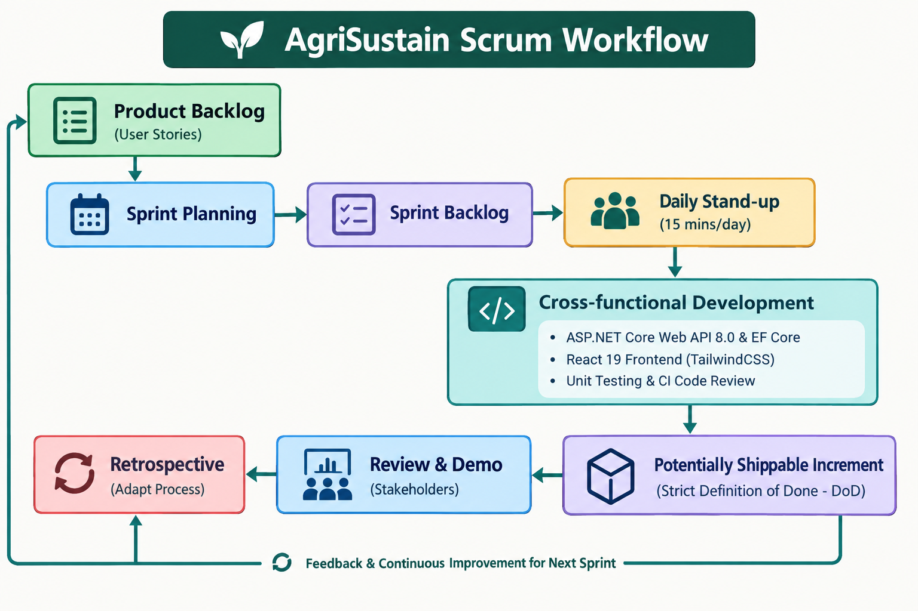

1.2 Scrum Roles & Responsibilities
- Product Owner (PO) – Nguyễn Văn Huy (PM & Lead BA):
  - Owns and continuously refines the Product Backlog, prioritizing user stories based on business value (traceability QR, marketplace transactions, regional price transparency).
  - Establishes acceptance criteria for each story and approves user stories against the Definition of Done (DoD).
  - Serves as the primary liaison between the development team, the Project Supervisor, and agricultural domain advisors.
- Scrum Master (SM) – Trần Bá Tú (QA/QC Leader):
  - Enforces Scrum events, removes technical blockers, and shields the team from external distractions.
  - Tracks Sprint velocity, burndown charts on Jira, and ensures quality standards are respected during each Sprint.
- Development Team (Nguyễn Văn Huy, Ngô Đức Dự, Lò Mạnh Xum, Trần Bá Tú, Nguyễn Quang Thương):
  - Cross-functional engineering team responsible for database modeling, Web API construction, UI implementation, and test automation.
  - Self-organizes to commit to and complete the Sprint Backlog items during each iteration.

1.3 Scrum Events (Ceremonies)
- Sprint Planning (At the beginning of each Sprint — 2 to 3 hours):
  - The PO presents prioritized user stories from the Product Backlog.
  - The team defines the Sprint Goal, breaks stories into technical sub-tasks, estimates effort in hours/person-days, and forms the Sprint Backlog.
- Daily Scrum (Daily — 15 minutes via Discord/Google Meet or Face-to-Face):
  - Each member synchronizes work by answering:
    - What did I complete yesterday toward the Sprint Goal?
    - What will I work on today?
    - Are there any blockers or impediments in my path?
  - Tasks and sub-tasks are tracked and updated immediately on Jira.
- Sprint Review / Stakeholder Demo (End of each Sprint — 1 to 2 hours):
  - The team presents a working, potentially shippable increment deployed on the staging environment.
  - The Supervisor and team review completed features and collect feedback to adapt the upcoming Sprint Backlog.
- Sprint Retrospective (Immediately following Sprint Review — 1 hour):
  - The team inspects the process: What went well? What obstacles were encountered? What concrete improvements will be adopted in the next Sprint?
  - Action items for process, tooling, or collaboration improvements are documented and assigned.

2 Quality Management
Quality Management is integrated continuously across every Sprint rather than deferred to an isolated phase at the end of the project. The team employs a multi-tiered Quality Assurance (QA) and Quality Control (QC) strategy guided by an unambiguous Definition of Done (DoD).

2.1 Definition of Ready (DoR) and Definition of Done (DoD)
- Definition of Ready (DoR): A user story is allowed into a Sprint Backlog only when:
  - Business rules, wireframe/UI flow, and acceptance criteria are clearly specified.
  - Data model dependencies (ERD, table relationships) are confirmed.
  - The story is estimated and agreed upon by the Development Team.
- Definition of Done (DoD): A Product Backlog Item is marked Done and demoed during Sprint Review only when:
  - Backend API endpoints and frontend React components are fully implemented per SRS specifications.
  - Code adheres to team coding standards (C# Clean Architecture / React Component Guidelines).
  - Peer Code Review is completed with at least 1 approval on GitHub Pull Request; branch protection rules pass.
  - Automated Unit Tests pass with a code coverage target >= 70% for critical domain logic.
  - Test cases executed in QA environment pass with zero Critical (P1) or Major (P2) open defects.
  - Database migrations and seed scripts are committed and verified.
  - The feature is merged into the dev branch and deployed to the Microsoft Azure staging server.

2.2 Defect Prevention
Defect prevention activities identify vulnerabilities and logical inconsistencies before code is written:
- Backlog Refinement & Acceptance Criteria Check: The PO, Tech Leads, and QA review user stories and data business rules (e.g., batch stock validation, unique tax code, certificate expiry logic) prior to Sprint Planning.
- Architecture & API Contracts: Standardized DTOs, Swagger/OpenAPI documentation, and database schemas are established before frontend and backend implementation begin.
- Static Code Analysis & Linters: SonarQube / ESLint / .NET Roslyn Analyzers are integrated into developer IDEs and GitHub Actions CI pipelines to detect code smells and security risks early.

2.3 Continuous Review Process
- Document & Spec Review: Requirement documents (SRS), system architecture (SDS), and test plans are reviewed collaboratively by the BA, Tech Leads, and Supervisor.
- Peer Code Review: Every code change requires a GitHub Pull Request (PR). Direct pushes to main and dev branches are prohibited. At least one technical lead (Backend Lead or Frontend Lead) must review the PR for correctness, edge-case handling, SQL optimization, and maintainability before merging.

2.4 Testing Strategy
Testing is conducted incrementally throughout each Sprint cycle:
- Unit Testing:
  - Written by developers during implementation.
  - Focuses on isolated core business logic: dynamic price calculation, cart totals, batch deduction algorithms, password hashing, and token validation.
  - Built using xUnit and Moq for backend service logic, while frontend verification is conducted primarily through component integration and manual functional test cases. .
- Integration Testing:
  - Verifies communication across decoupled services, repositories, and APIs:
    - Entity Framework Core interactions with SQL Server database.
    - VietQR / PayOS payment webhook handling and transaction status transitions.
    - Google Gmail Notification API integration for OTP and alerts.
- System Testing:
  - Conducted on complete, integrated builds deployed on Azure staging.
  - Executes end-to-end user workflows: Farmer onboarding & KYC $→$ Product listing $→$ QR Batch creation $→$ Consumer checkout with PayOS $→$ Order fulfillment & QR scanning.
- User Acceptance Testing (UAT):
  - Facilitated at milestone releases and Sprint Reviews with sample test scenarios representing authentic farmer and buyer personas.
  - Confirms that business requirements and usability expectations are satisfied.

2.5 Defect Management Workflow
Defects identified during automated testing, QA execution, or Sprint Reviews are logged and tracked centrally in Jira:
- Log & Classify: Tester captures detailed reproduction steps, expected vs. actual behavior, screenshots/network logs, and assigns severity:
  - Critical (P1): System crash, data loss, payment webhook failure, security breach. Must be fixed immediately.
  - Major (P2): Major feature broken (e.g., checkout blocked, batch stock discrepancy) with no workaround. Must be resolved within current Sprint.
  - Minor (P3): UI misalignment, minor validation message text defect. Scheduled based on priority.
- Triage & Assignment: Scrum Master and PO assign bugs to developers during daily stand-ups or backlog grooming.
- Fix & Retest: Developer commits fix via bugfix/* branch, links Jira ticket to GitHub PR, and deploys update.
- Verification & Closure: QA retests the defect on staging. Upon successful validation, the ticket is moved to Closed.

3. Project Training Plan
The Training Plan identifies the knowledge and technical skills required by the project team to successfully implement AgriSustain. Training activities are scheduled before or during the project phase in which the corresponding knowledge is required.
Training is conducted through self-study, technical documentation, internal knowledge sharing, practical exercises, small prototypes, and supervisor guidance where applicable.

Training Area | Participants | When, Duration | Waiver Criteria
Agile/Scrum & Project Workflow | All members | Week 1 (Sprint 0), 1 session | Mandatory
Git, Github | All members | Week 1 (Sprint 0), 1 session | Mandatory
Agricultural Domain & Business Requirements | BA and related members | Week 2, 2 sessions | Mandatory
Requirements & Use Case Analysis | BA and related members | Week 2, 2 sessions | Mandatory
Clean Architecture & System Design | Developers | Weeks 3–4, 2 sessions | Mandatory
ASP.NET Core Web API, EF Core & SQL Server | Developers | Weeks 3–4, 3 sessions | Mandatory
React Frontend Development | Developers | Weeks 3–4, 2 sessions | Mandatory
Software Testing | Developers and Testers | Week 5, 2 sessions | Mandatory
Traceability & QR Technology | Assigned members | Week 5, 1 session | Mandatory
Deployment & System Configuration | Assigned Developers | Week 7, 1 session | Mandatory

4. Responsibility Assignments

4.1. Project Organization

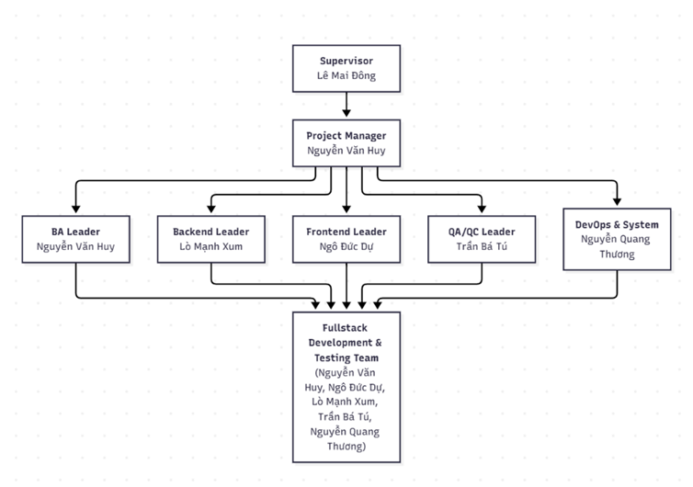4.2. Role and Responsibilities

# | Member | Roles
1 | Lê Mai Đông | Supervisor (Lecturer - Lecturer in Software Engineering Faculty of FPT University)
2 | Nguyễn Văn Huy | Project Manager, Business Analyst Leader, Fullstack Developer
3 | Lò Mạnh Xum | Backend Leader, Database Architect, Fullstack Developer
4 | Ngô Đức Dự | Frontend Leader, UI/UX Designer, Fullstack Developer
5 | Trần Bá Tú | QA/QC Leader (Test Leader), Fullstack Developer
6 | Nguyễn Quang Thương | DevOps & System Administrator, Fullstack Developer

4.3. Responsibility Assignment Matrix
The responsibility assignment is following the RACI Chart.
R, A, C, I stands for:
➢ R: Responsible
Responsible designates the task as assigned directly to this person (or group of people). The responsible person is the one who does the work to complete the task or create the deliverable. Every task should have at least one responsible person and could have several.
➢ A: Accountable
The accountable person in the RACI equation delegates and reviews the work involved in a project. Their job is to make sure the responsible person or team knows the expectations of the project and completes work on time. Every task should have only one accountable person and no more.
➢ C: Consulted
Consulted people provide input and feedback on the work being done in a project. They have a stake in the outcomes of a project because it could affect their current or future work.
➢ I: Informed
Informed folks need to be looped into the progress of a project but not consulted or overwhelmed with the details of every task. They need to know what’s going on because it could affect their work, but they’re not decision makers in the process.
So that we define the responsibility assignment table as follow:

Responsibility | Huy NV | Du ND | Xum LM | Tu TB | Thuong NQ | Dong LM
PHASE 1: REQUIREMENT ANALYSIS
Gather Requirements & Business Rules | A/R | R | R | R | R | C
Software Requirement Specification (SRS) | A/R | R | R | R | R | C
Use Case Diagram & Main Workflows | A/R | R | R | R | R | C
PHASE 2: SYSTEM DESIGN
System Architecture Design | C | C | A/R | C | R | C
Database Design (ERD & Data Dictionary) | C | C | A/R | C | R | C
UI/UX Design (Mockups & Wireframes) | C | A/R | C | R | R | C
Class Diagram & Sequence Diagrams | C | C | A/R | C | R | C
Software Design Document (SDS) | R | R | A/R | R | R | C
Decide Tech Stack & Infrastructure | A/R | R | R | R | R | C
PHASE 3: IMPLEMENTATION
Code Backend Modules | R | R | A/R | R | R | I
Code Frontend Modules | R | A/R | R | R | R | I
Write Unit Tests & Log Bugs | R | R | R | A/R | R | I
Source Code Management (Git/Azure Repos) | R | R | R | R | A/R | I
PHASE 4: TESTING & QA
Create Test Plan & Test Documentation | C | C | C | A/R | C | C
Create Integration Test Cases | R | R | R | A/R | R | I
Create System Test Cases | R | R | R | A/R | R | I
Create Acceptance Test Cases | A/R | R | R | R | R | C
Execute Test Cases & Bug Tracking | R | R | R | A/R | R | I
Test Report & Quality Assessment | C | I | I | A/R | I | I
PHASE 5: DEPLOYMENT & PROJECT CLOSURE
Deploy Web App to Server Cloud | R | R | R | R | A/R | I
Create Software User Guide | R | A/R | R | R | R | C
Final Project Report | A/R | R | R | R | R | C
Presentation Slides & Demo Preparation | A/R | R | R | R | R | C

5. Project Communications

Communication Item | Who/ Target | Purpose | When, Frequency | Type, Tool, Method(s)
Project Team Meeting | All project members | Discuss project progress, assign tasks, discuss problems and coordinate development | Weekly / When needed | Online meeting, face-to-face, Discord/Zalo
Project Progress Report | Project Manager / Lecturer | Report project progress, completed tasks, difficulties and upcoming work | Weekly | Document, Google Docs
Requirement Discussion | All team members / Lecturer | Discuss and clarify requirements | When needed | Discord/Zalo
Task Assignment & Tracking | Project members | Assign tasks, track progress and ensure each member completes their responsibility | Weekly / Daily | GitHub Projects/Zalo
Code Review | Developers / Team Leader | Review code quality, detect errors and ensure coding standards | After completing a feature | GitHub Pull Request, code review
Testing Report | Developers / Tester / Team Leader | Record test results, bugs and current system quality | After each major feature / Before release | Test document, Excel/Google Sheets
Final Presentation | Lecturer / Team members | Present the completed system, main problems, solutions and project results | At project submission/presentation | PowerPoint, Demo system, Face-to-face

6. Configuration Management

6.1 Document Management
Our team uses Google Workspace for document management and collaborative editing. All our files are stored in a shared team folder on Google Drive, ensuring seamless access and editing for all members. The system automatically tracks version history, recording both the author and timestamp of every change.
Alongside Google Docs, we also utilize WPS Office whenever more flexible formatting options are required.
Management Tools:
- Google Docs: Creating project reports and user manuals
- Google Sheets: Project tracking and test case management
- Canva: Presentations and visual documentation
- Jira: Managing sprint and task progress, workflows, and defect/bug lifecycle tracking throughout the testing phase

6.2 Source Code Management
Our team utilizes GitHub for source code management and version control. Built on Git’s distributed architecture, GitHub provides a centralized repository hosting platform that enables seamless, transparent tracking of commit histories and code modifications. The system allows team members to work concurrently on the same project without conflicts or accidental overwrites:
- Branches: Allow developers to branch off independently from the main codebase to build new features or resolve bugs without compromising system stability.
- Pull Requests (PR): Before merging new code into shared branches, developers are required to create a Pull Request. This workflow enables peer code reviews, discussions, and early detection of logical or syntax errors prior to merging.
- Version History & Commit Log: GitHub maintains a comprehensive log of all changes, including commit authors, timestamps, and line-by-line code diffs.
- Security & Branch Protection: The team enforces access control mechanisms and configures Branch Protection Rules to prevent direct pushes to critical branches without prior review and approval.
- Repository Structure: The project is decoupled into two separate repositories to ensure modular independence between the development layers:
  - Front-End Repository: Hosts all user interface source code (React), static assets, and client-side configurations.
  - Back-End Repository: Houses server-side services (ASP.NET Web API), business logic, database connection setups, and associated dependencies.
GitHub Branching Strategy
- main (Production Branch):
  - Contains the most stable production-ready code, having passed all testing phases and QA checks.
  - Direct pushes are strictly prohibited; updates are received exclusively via merges from the dev branch upon sprint or release completion.
- dev (Development Branch):
  - Serves as the central integration branch for the entire development team.
  - Feature and bugfix branches are merged into dev via Pull Requests after passing peer review and automated tests.
- Feature & Bugfix Branches (feature/*, bugfix/*):
  - Team members branch off individually from dev to work on assigned tasks.
  - Once completed, changes are pushed to GitHub, and a Pull Request targeting dev is opened.
All code contributions and commit activities are centrally managed within the team's GitHub organization. Access links to the project assets are provided below:
- Organization / Project: SEP490_G62
- Backend Repository: Backend Repository - SEP490_G62
- Frontend Repository: Frontend Repository - SEP490_G62

6.3 Tools & Infrastructures
Category | Tools / Infrastructure
Technology | Frontend: React 19.1.0, Backend: ASP.NET Web API 8.0
Database | MS SQL Server
IDEs/Editors | Visual Studio Code, Visual Studio 2022
Diagramming | DrawIO, Visual Paradigm
Documentation | WPS Office, Google Docs/Sheets
Version Control | GitHub (Source Codes), Google Drive (Documents)
Deployment server | Microsoft Azure
Project management | Jira (Schedule, Tasks, Defects, Issue Management)

